RESEARCH REPORT

*by* Prajwal B S

**Submission date:** 24-Jun-2022 07:52AM (UTC-0700)

**Submission ID:** 1862334915

**File name:** re4searchpaper_driver.docx (1.76M)

**Word count:** 1769

**Character count:** 8903

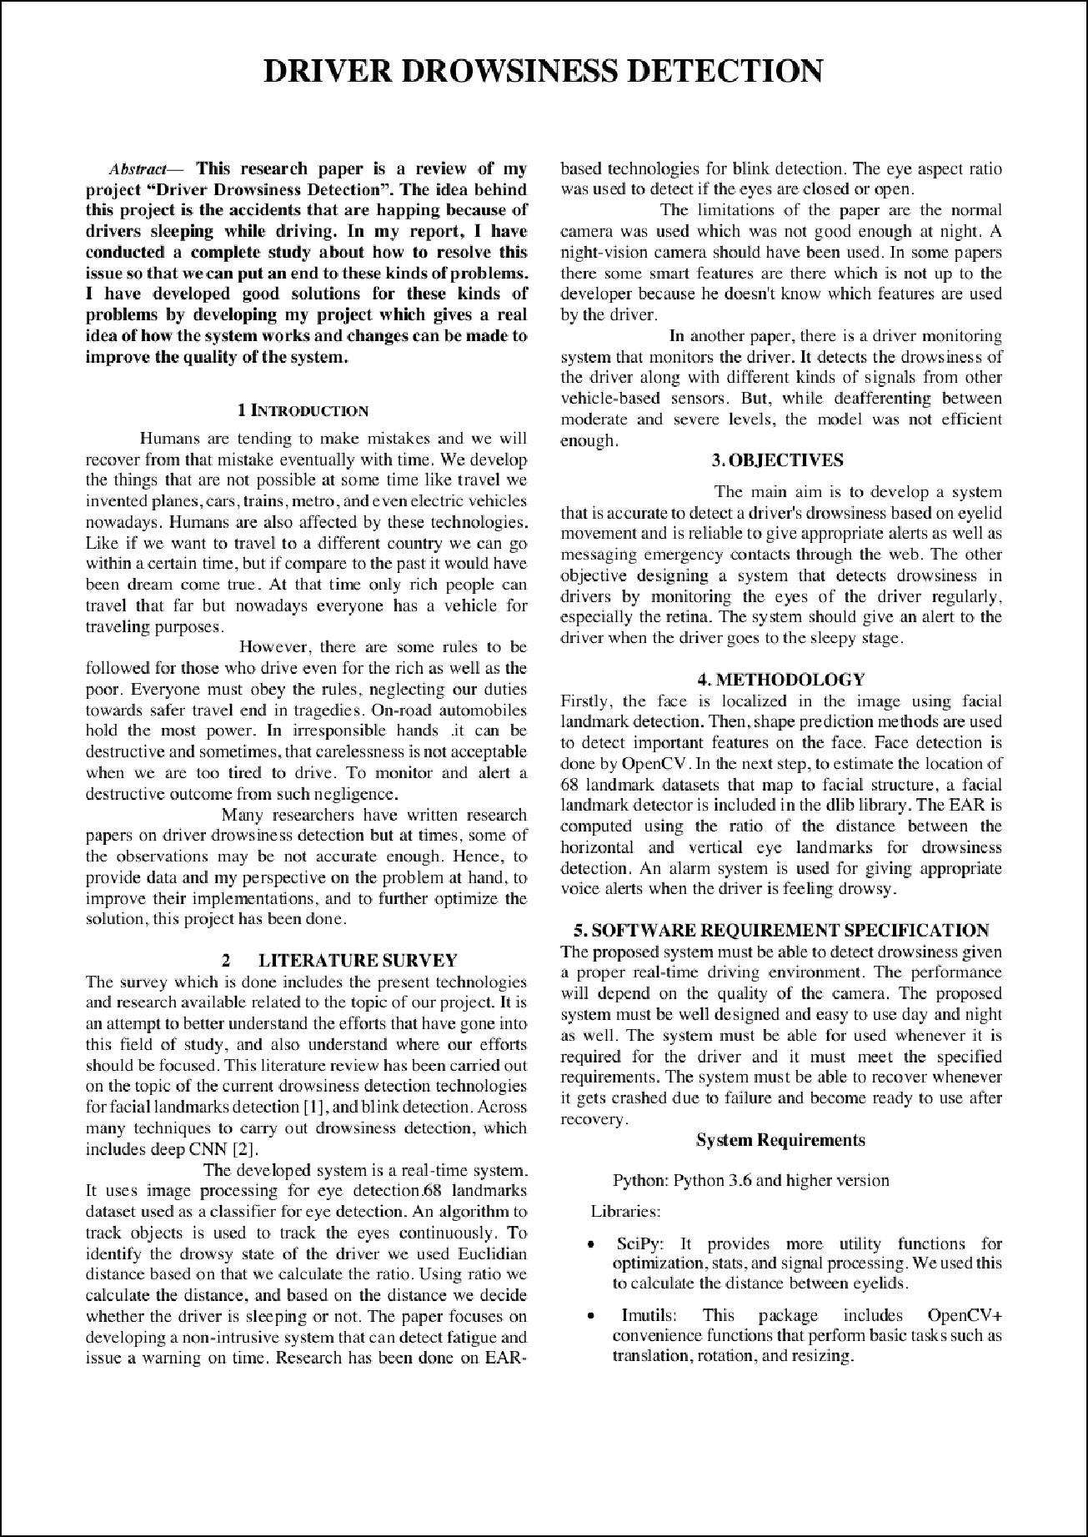

1

1

1

3

1

1

1

1

3

3

1

1

3 1

1

1

1

2 11

2

2 9

1

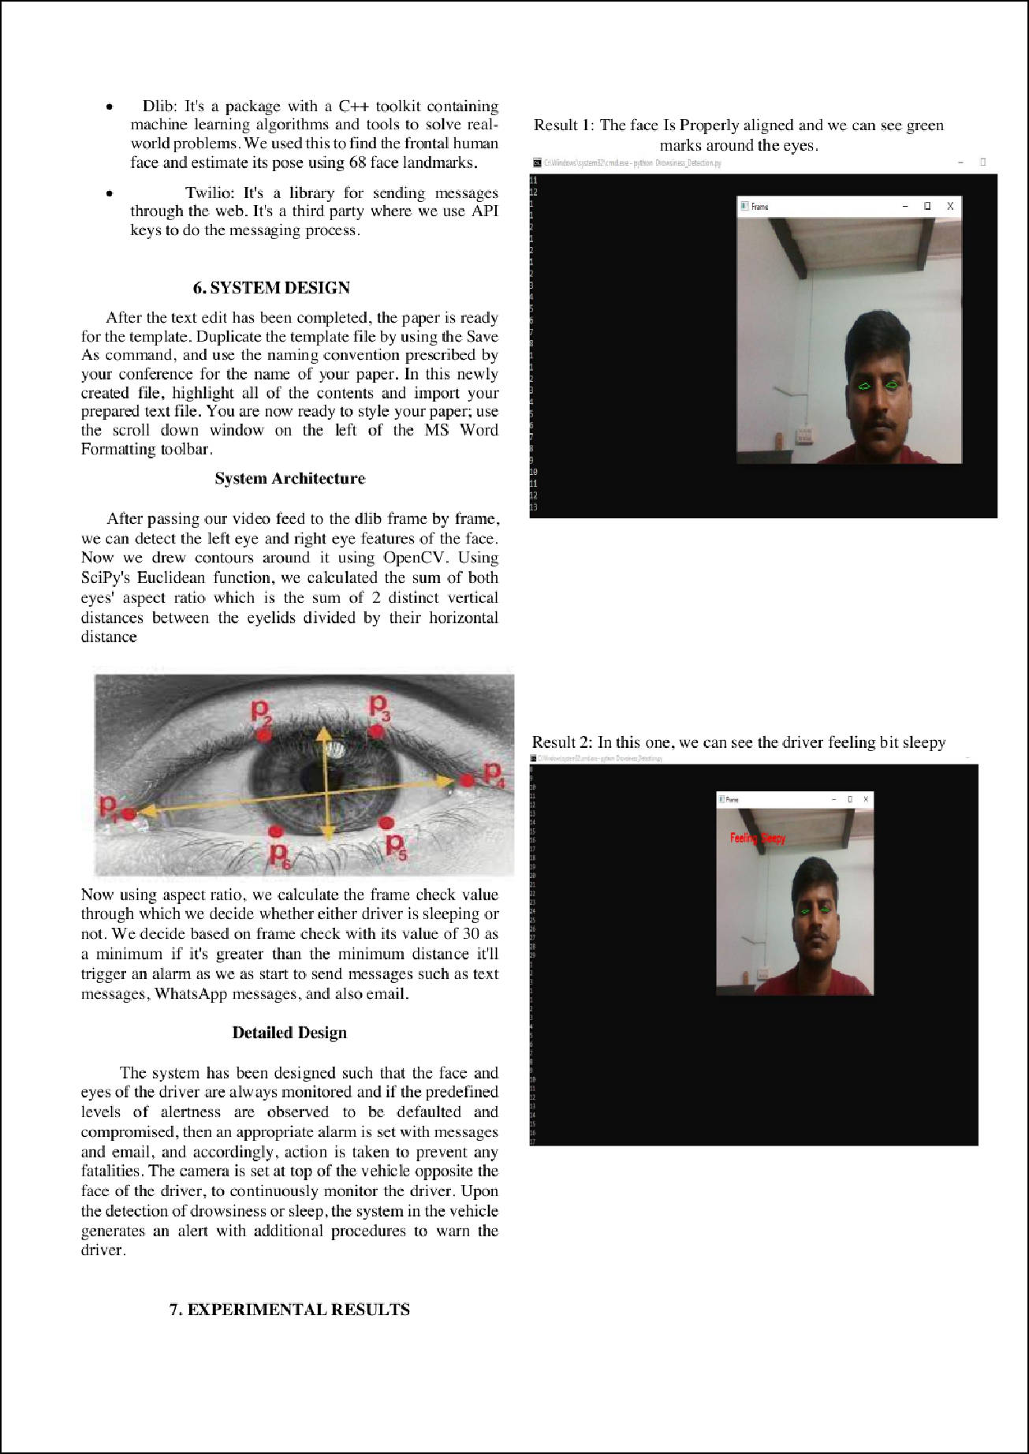

3

2

4

1

1

1

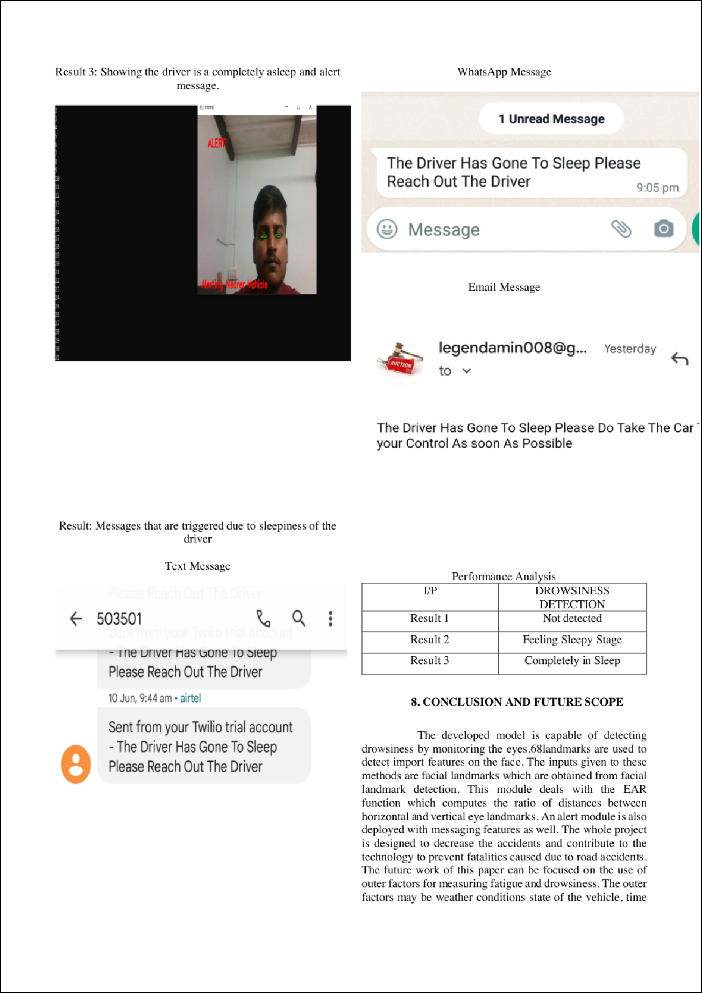

1

1

1

1

1

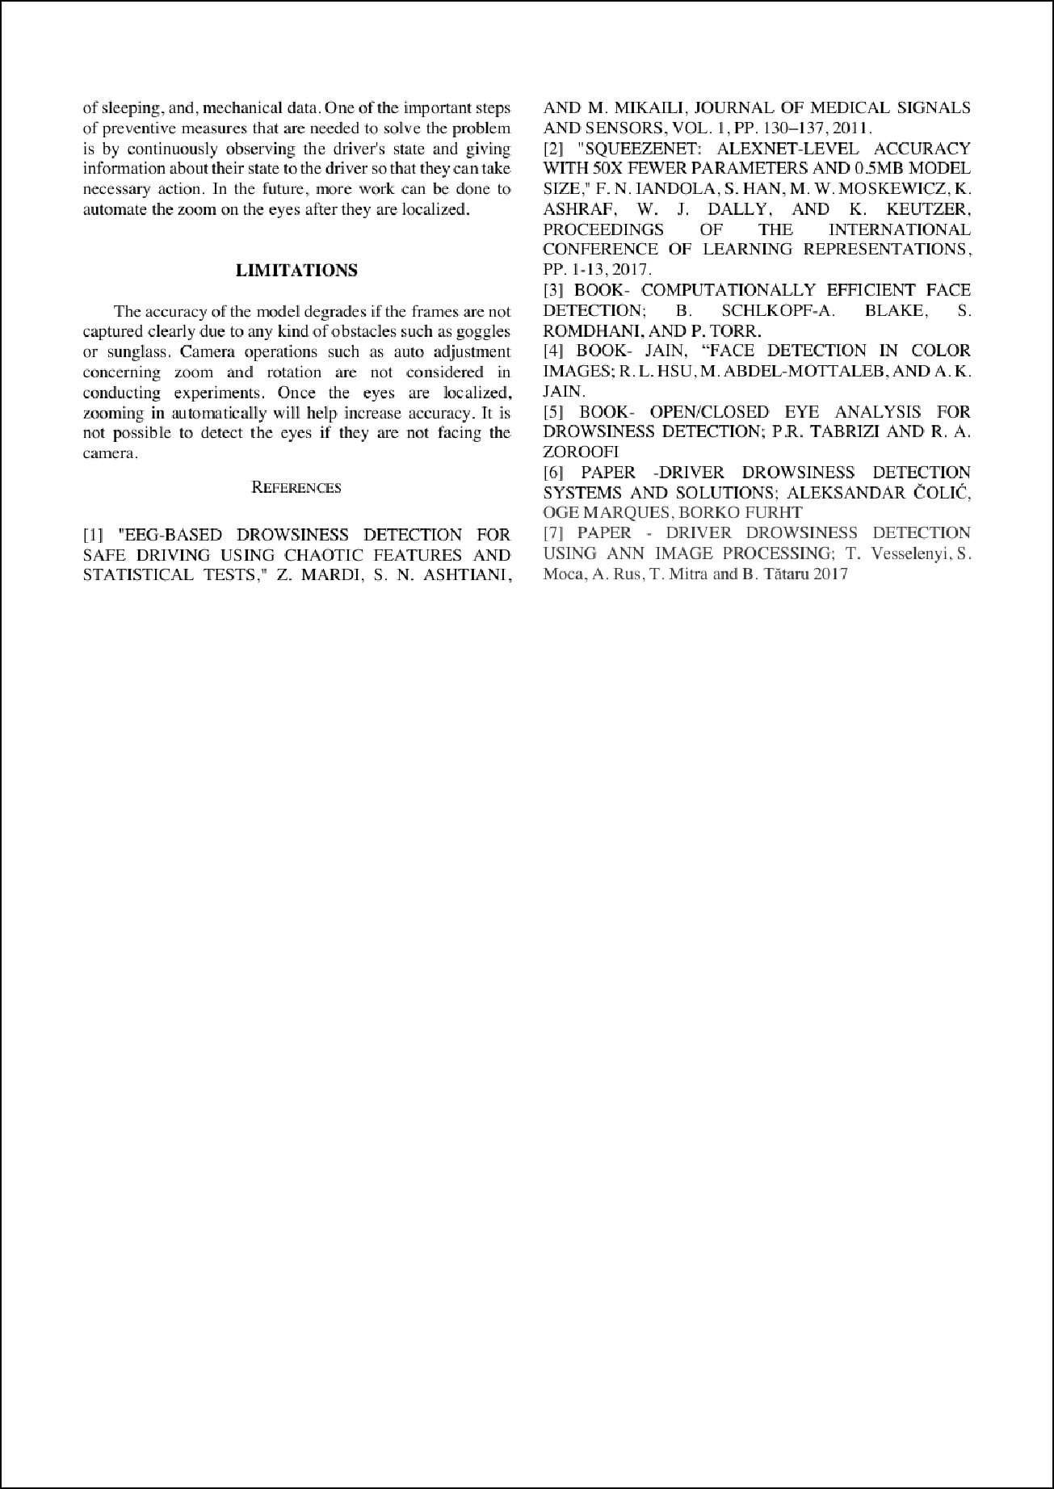

1 1

8

1

1

1

3

5

1

10

7

6

## RESEARCH REPORT

60

ORIGINALITY REPORT

## %

SIMILARITY INDEX

60%

INTERNET SOURCES

21%

PUBLICATIONS

30%

STUDENT PAPERS

PRIMARY SOURCES

# [www.ijeat.org](http://www.ijeat.org/)

1

Internet Source

# [www.ijert.org](http://www.ijert.org/)

2

Internet Source

# [www.researchgate.net](http://www.researchgate.net/)

3

Internet Source

# [www.irjmets.com](http://www.irjmets.com/)

4

Internet Source

# Submitted to Bournemouth University

5

Student Paper

# iopscience.iop.org

6

Internet Source

# [www.ncbi.nlm.nih.gov](http://www.ncbi.nlm.nih.gov/)

7

Internet Source

# [www.slideshare.net](http://www.slideshare.net/)

8

Internet Source

# towardsdatascience.com

9

Internet Source

36%

7%

7%

3%

2%

1%

1%

1%

1%

### 10

11

# link.umsl.edu

Internet Source %

1

# [www.ijraset.com](http://www.ijraset.com/)

1

Internet Source %

Exclude quotes Oﬀ Exclude bibliography Oﬀ

Exclude matches Oﬀ